**Project Design Phase-II**

**Data Flow Diagram & User Stories**

|  |  |
| --- | --- |
| Date | 7 November 2022 |
| Team ID | PNT2022TMID07592 |
| Project Name | AI-Powered Nutrition Analyzer for fitness enthusiasts |
| Maximum Marks | 4 Marks |

**Data Flow Diagrams:**

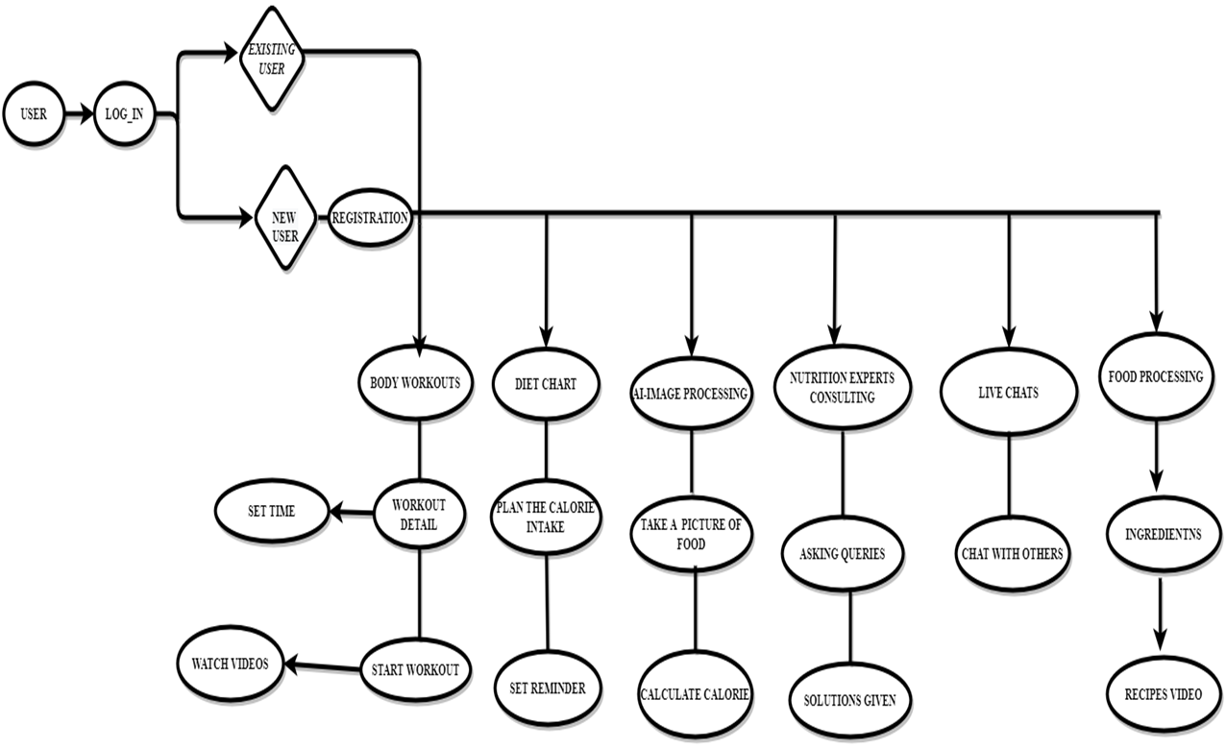

**User Stories**

Use the below template to list all the user stories for the product.

|  |  |  |  |  |  |  |
| --- | --- | --- | --- | --- | --- | --- |
| **User Type** | **Functional**  **Requirement**  **(Epic)** | **User Story**  **Number** | **User Story / Task** | **Acceptance criteria** | **Priority** | **Release** |
| Customer  (Mobile user) | Registration | USN-1 | As a user, I can register for the application by entering my email, password, and confirming my password. | I can access my account / dashboard | High | Sprint-1 |
|  |  | USN-2 | As a user, I will receive confirmation email once I have registered for the application | I can receive confirmation email & click confirm | High | Sprint-1 |
|  |  | USN-3 | As a user, I can register for the application through Facebook | I can register & access the dashboard with Facebook Login | Low | Sprint-2 |
|  |  | USN-4 | As a user, I can register for the application through Gmail | I can receive confirmation mail through Gmail | Medium | Sprint-1 |
|  | Login | USN-5 | As a user, I can log into the application by entering email & password | I can log into the system using the Email & password | High | Sprint-1 |
|  | Dashboard | USN-6 | Not Required |  |  |  |
| Customer (Web user) | Data Setup | USN-7 | As a User, I will enter my Data’s which includes Height, Weight, Age & Gender | I can include the data contents in the application | High | Sprint-1 |
| Customer Care Executive | Queries | USN-8 | As a User, I can raise and submit their queries in the Q&A section. | I can raise the queries  how to use the application in Q&A | Medium | Sprint-2 |
| Administrator | Diet Chart | USN-9 | User can customize the Diet chart based upon their Maintenance calorie | I can customize the diet chart. | High | Sprint-1 |
|  | Liquid Intake | USN-10 | User can add the amount water they consume and get the hourly reminder to consume water | I can include the data contents in the application | Medium | Sprint-2 |
|  | Workout | USN-11 | I can add the customized workout to do on a daily basis. | I can do the daily workout session. | High | Sprint-1 |
|  | Community Chart | USN-12 | User can create a community and chat with them accordingly | I can do the daily workout session. | Medium | Sprint-2 |